Save The Date January 27, 2018
DAZED AND CONFUSED?
BITS, BRIDLES AND EQUIPMENT
HOW NOT TO GET ELIMINATED
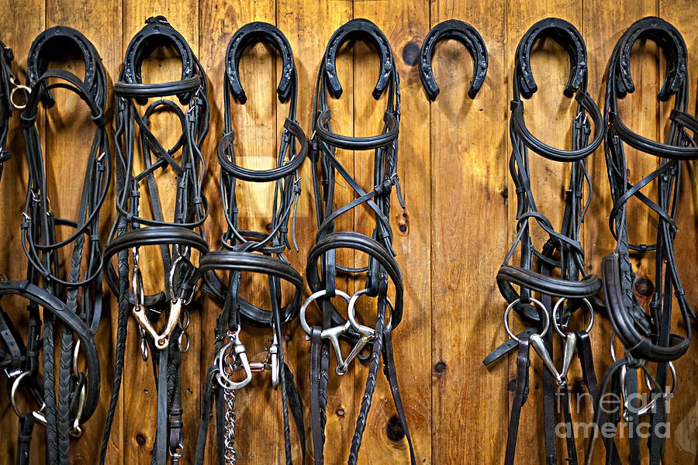
Speakers: Susan Moran and Karen Winn
Place: Kentucky Riding For Hope
This is a MSEDA Officials continuing education forum. All auditors will be welcome.
Fee: $50 MSEDA Official, $25 auditor
More information coming soon.

